Location: home/index.html

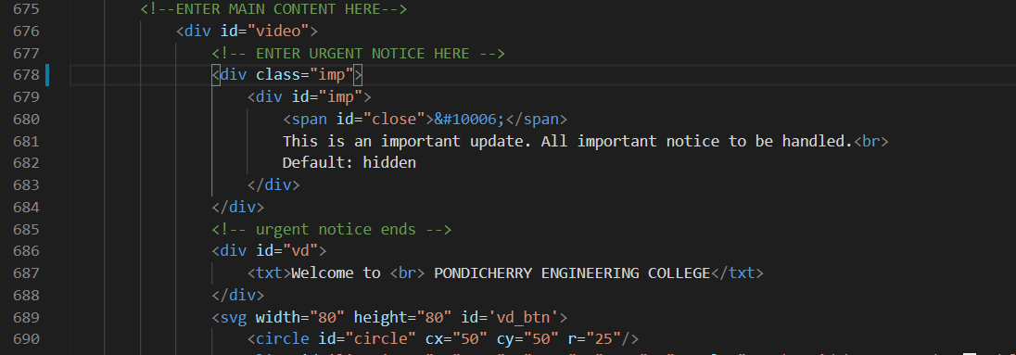

This feature is hidden and should be enabled by removing the display:none inline style in div ‘imp’.

The message should be kept short and within 30 words for best viewability.

